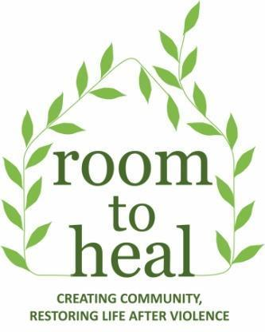
Referral Consent Form
Name: ………………………………………
Date: __/__/____

Room to Heal is committed to maintaining your confidentiality at all times. We comply with the Data Protection Act (2018) and the General Data Protection Regulation (GDPR). In order to be able to support you, Room to Heal needs to store, share and protect your data in a number of ways. To do this, we require your consent.

Please read the following sections carefully, and let us know that you understand and agree by ticking the box in each section, and signing your name and date at the end of this form.

1. Referral

I give consent to Room to Heal to hold all my personal information, that is provided to them now and in future for purpose of Room to Heal being able to provide me with therapeutic and casework assistance. All of my personal and sensitive data will be stored securely within Room to Heal. I understand that Room to Heal will need to process my personal data to provide me with casework assistance and therapy.

Yes ☐ No ☐

2. Sharing information about me with my referrer

a) Room to Heal may need to speak to and share information about me with my referrer, to let them know whether my referral was successful, or to ask for further information. Room to Heal will also work to communicate with me about further information required.

Yes ☐ No ☐

3. Using my information to help Room to Heal raise funds and improve its services

a) Room to Heal shares anonymised details of their work with people and organisations - for example funders - so that they may choose to support the charity. This is called research information. For example, Room to Heal will tell them how many people they help, how many attend initial assessments, and how many people join the therapy groups. When they do this, they do not give any information to anyone that will identify me, such as my name or my address, without my permission.

Yes ☐ No ☐

4. Using my contact details to get in touch with me and invite me to an appointment

I give consent to Room to Heal’s staff to contact me where necessary, for example to invite me to an initial assessment. I understand that Room to Heal staff will save my contact details for these purposes.

Yes ☐ No ☐

5. Storing and sharing my personal information

b) My personal information will be recorded and stored securely in paper and/or electronic files as necessary. Paper files are secured in locked filing units, and electronic files are saved in our encrypted and secure database.

c) My personal information will be shared securely, with the above mentioned people and organisations, through an encrypted email server. If Room to Heal ever thinks that it has somehow compromised my personal information, I will be notified straight away.

d) I understand that Room to Heal will not release my personal electronic data unless required by law or where there is a clear overriding public or vital interest in disclosure. However, where possible, I will be told if any disclosure is to take place.

Yes ☐ No ☐

Signature: _______________________ Date: ______________

Please note:
If you do not wish to grant Room to Heal consent to hold any of your personal data for the above-mentioned purposes, you are in no obligation to sign this consent form.
However, in the case you do not wish to grant us consent to process your data for the purposes of membership, referral and third party communications, you may not be able to access our full services and we may not be able to fully assist you to the best of our abilities.
You are allowed to withdraw consent from Room to Heal at any point and for any reason. To do this, you can:
- Orally express your desire to withdraw consent to any member of staff
- Email Anna at anna@roomtoheal.org
- Call us at 0207 923 2007

We will ask you to sign a consent withdrawal form. We may ask if you would like to share your reasons for withdrawing consent from Room to Heal. We will dispose of all your personal data securely and permanently following your request.

Please find our Privacy Notice attached.

